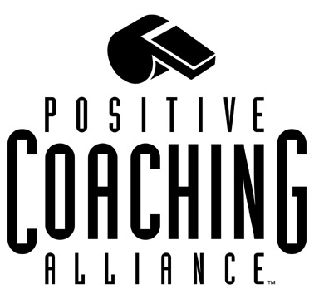

PCA Partnership Program

The PCA Local Partners Program is a one-year, renewable collaboration between Positive Coaching Alliance and a local youth sports organization (YSO), which has the goal of becoming an outstanding educational-athletic organization. The Partnership program is designed to help your leaders, coaches and parents to establish a culture that helps young athletes develop the values, habits, and skills they need to become successful as athletes and as citizens.

Partnership Program
The Partnership Program provides the following 3 workshops (6 hours total) . Your organization receives a Leadership, a Coaches and a Sports Parent workshop. The fee is $2,200 + $5 per attendee. Additional workshops are available at a rate of $500. Partnerships can also be customized to fit the specific workshop needs of your organization.

Leadership Workshop
Gives youth sports organization leaders and board members practical tools for creating and attaining an organizational culture that is conducive to positive coaching in the short and long term. Leaders will be provided with tools that help them promote the values and behavior they want to see in their coaches, fans and athletes. Time: 2 hours.

Double-Goal Coach Workshop (levels I, II & III available)
Provides coaches of all sports with tools they can use to become "Double-Goal" coaches (coaches who want to both win and develop the character of their players). This interactive workshop stresses not only the importance of developing a positive culture around youth sports, but also provides concrete steps coaches can take to make this a reality. Time: 2 hours.

Sports Parent Education Workshop
For parents who want to help their children get the most from the youth sports experience. The workshop addresses how parents can help coaches and league administrations establish and maintain a positive competitive environment.
Time: 2 hours.

To supplement the above workshop details, I'd like to clarify the PCA pricing model.

-Single workshop~ $1,200 plus $5 per attendee
-Two workshops ~ $1,700 plus $5 per attendee

- Partnership (3 workshops) ~ $2,200 plus $5 per attendee. Additional workshops during the same PCA trip, are available at $500 each. In order to qualify for the above pricing, partners who wish to conduct multiple workshops must “cluster”, or arrange, these workshops over a 1-3 day period. (So that PCA trainers can meet your needs in a single trip, versus multiple trips.)

Note: Travel related expenses are in addition to the above Partnership Fees.

Become a PCA Partner, Today!

Contact Jan Merryweather at jan@positivecoach.org ; or, #650/736-1365

